DAA Practical 10 – Kruskal's Algorithm (MST)
Design and Analysis of Algorithms

Aim
To implement Kruskal's Algorithm to find the Minimum Spanning Tree (MST) of a connected weighted graph.

Kruskal's Algorithm

1. Algorithm
Algorithm: Kruskal's Algorithm (Minimum Spanning Tree)

Aim:
To find a Minimum Spanning Tree (MST) of a connected weighted graph
by selecting edges in increasing order of weight without forming a cycle.

Input:
- Connected weighted graph with vertices and edges

Output:
- Edges present in the MST
- Total cost of the MST

Steps:
1. Start
2. Sort all edges in increasing order of weight
3. Create a separate set for each vertex (parent array)
4. Set total_cost = 0 and selected_edges = 0
5. Take the next cheapest edge (u, v, w)
6. If u and v belong to different sets (no cycle) then
Add edge (u, v) to MST
Join the two sets
total_cost = total_cost + w
selected_edges = selected_edges + 1
7. Repeat steps 5 and 6 until selected_edges = V - 1
8. Print MST edges and total_cost
9. Stop

Idea:
Always pick the cheapest remaining edge.
Add it only if it does not create a cycle.
Stop when all vertices are connected (V - 1 edges).

Difference from Prim:
- Prim grows MST from one starting vertex
- Kruskal picks global cheapest edges anywhere in the graph

Example Graph:
A-B:2, A-D:6, B-C:3, B-D:8, B-E:5, C-E:7, D-E:9

Sorted edges: 2, 3, 5, 6, 7, 8, 9
MST edges:
A - B : 2
B - C : 3
B - E : 5
A - D : 6
Total cost = 16

Time Complexity: O(E log E) (mainly due to sorting)
Space Complexity: O(V)

Where V = vertices, E = edges

2. Program Code (C Language)
File: Code/kruskal.c
#include <stdio.h>

#define MAX 20

/*
Kruskal's Algorithm
Find Minimum Spanning Tree (MST)
Pick cheapest edges that do not form a cycle
*/

// Edge structure: from, to, weight
struct Edge
{
int u, v, w;
};

char name[] = {'A', 'B', 'C', 'D', 'E'};
int parent[MAX];

// find root of a vertex (for cycle check)
int find(int x)
{
if (parent[x] == x)
return x;
return find(parent[x]);
}

// join two sets
void unite(int a, int b)
{
int rootA = find(a);
int rootB = find(b);
parent[rootA] = rootB;
}

int main()
{
// same graph used in Prim's practical
// A-B:2, A-D:6, B-C:3, B-D:8, B-E:5, C-E:7, D-E:9
struct Edge edges[7] = {
{0, 1, 2}, // A-B
{0, 3, 6}, // A-D
{1, 2, 3}, // B-C
{1, 3, 8}, // B-D
{1, 4, 5}, // B-E
{2, 4, 7}, // C-E
{3, 4, 9} // D-E
};

int n = 5; // number of vertices
int e = 7; // number of edges
int i, j;
int total_cost = 0;
int mst_edges = 0;

// sort edges by weight (simple bubble sort)
for (i = 0; i < e - 1; i++)
{
for (j = 0; j < e - i - 1; j++)
{
if (edges[j].w > edges[j + 1].w)
{
struct Edge temp = edges[j];
edges[j] = edges[j + 1];
edges[j + 1] = temp;
}
}
}

// each vertex is its own parent at start
for (i = 0; i < n; i++)
parent[i] = i;

printf("Edges in Minimum Spanning Tree:\n");

// pick edges one by one (cheapest first)
for (i = 0; i < e; i++)
{
int u = edges[i].u;
int v = edges[i].v;
int w = edges[i].w;

// if u and v are in different sets, no cycle
if (find(u) != find(v))
{
printf("%c - %c : %d\n", name[u], name[v], w);
unite(u, v);
total_cost = total_cost + w;
mst_edges++;
}

// MST is complete when we have n-1 edges
if (mst_edges == n - 1)
break;
}

printf("Total cost of MST: %d\n", total_cost);
printf("Time Complexity: O(E log E)\n");
printf("Space Complexity: O(V)\n");

return 0;
}

3. Output
Sample program output:
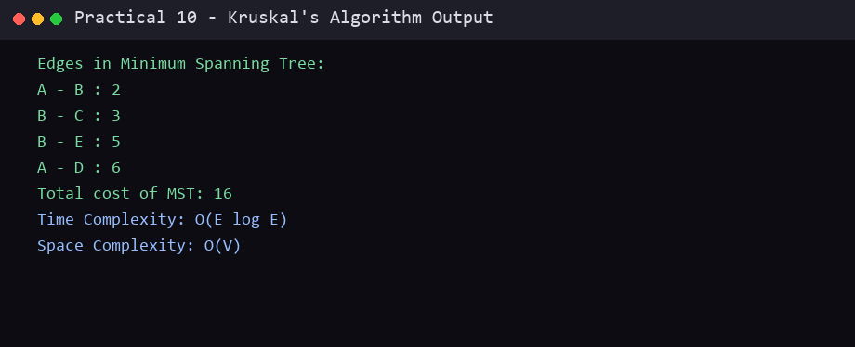

Conclusion
In this practical, the required algorithm was studied and implemented successfully in C. The algorithm, program code and sample output are recorded above. This practical helped in understanding the working and complexity of the technique used.
End of Practical 10

